ASU – IFT 482

Activity Cover Sheet
Name:  Elton Robert Rushlau IV | Professor:  Helm

Activity – Project 1

Title of Report:

Project 1

Summary (two sentences):
This activity aims to offer a comprehensive insight into various facets of protocol analysis for computer forensics examiners proficient in basic networking. Examiners must possess a solid understanding of the protocols encompassing the Transmission Control Protocol/Internet Protocol (TCP/IP) suite to thoroughly comprehend the contents of logs and data packets.

Checklist (items included):
1. Cover Sheet |  | 4. Results: Data, Tables, & Diagrams
2. Introduction & Background |  | 5. Analysis of Results
3. Procedure |  | 6. Summary and Conclusions

Key Results:
During this learning experience, I significantly enhanced my proficiency in utilizing Wireshark and Nmap for network analysis and reconnaissance. Within Wireshark, I deepened my understanding of packet filtering techniques, enabling me to refine and optimize the capture of network traffic. Moreover, I honed my skills in pinpointing port information within packet captures, thereby enhancing my ability to identify network services and anomalies.

Furthermore, I expanded my expertise in conducting local device scans using Nmap, mastering various scan types including TCP, SYN, and UDP scans. Through practical application, I became adept at implementing Nmap scans to systematically explore network hosts and uncover open ports, providing invaluable insights into network topology and potential security vulnerabilities.

Key Conclusions (technical):
During this activity, we delved into a multitude of scans utilized for host discovery, understanding their nuances and applications in uncovering hosts and the services operating on them. Exploring techniques such as TCP connect scans, SYN scans, and UDP scans equipped us with the ability to identify hosts and the services they offer. Additionally, we extensively explored the functionalities of Wireshark, a powerful packet capture and analysis tool, learning how to effectively capture packet traffic and conduct in-depth analysis to glean insights into network behavior, anomalies, and security threats. Through hands-on exercises and practical applications, we honed our skills in leveraging Wireshark's features to dissect packet flows, decipher protocols, and identify potential security vulnerabilities, thereby bolstering our proficiency in network analysis and forensics.

Key Conclusions (critical thinking):
Obtaining comprehensive information about the network serves as the foundational stage in network forensics, playing a pivotal role in subsequent investigative procedures. The insights gained from studying various sniffing techniques and host discovery tools are indispensable, providing essential capabilities for identifying network assets, anomalies, and potential security breaches. Without a thorough understanding of the network landscape, investigators would encounter significant challenges in pinpointing the target and formulating strategic approaches to progress further in the investigation process. In essence, robust knowledge and proficiency in network reconnaissance techniques empower forensic analysts to navigate through intricate network environments, extract valuable evidence, and effectively mitigate security incidents.
Deliverables

Cover Sheet (5 Points)
Complete the cover sheet, including name, title, summary, key results, key conclusions (technical), and key conclusions (critical thinking).

Introduction (5 Points)
In this project, we will introduce two essential tools for network reconnaissance: Wireshark and Nmap. Through a structured step-by-step activity, participants will gain hands-on experience in operating Wireshark, mastering skills such as packet capturing, saving, reloading, and filtering. Moreover, we will explore the functionalities of Nmap, delving into its capabilities for host discovery within the network and its ability to perform various types of scans to unveil system services and open ports. The activity will provide insights into how Wireshark and Nmap can be used in tandem to achieve a comprehensive understanding of the systems within the network. By concurrently utilizing both tools, participants will deepen their knowledge of network architecture, traffic patterns, and vulnerabilities present within the environment. Through practical exercises and real-world scenarios, participants will develop proficiency in leveraging these tools to conduct thorough network assessments, identify potential security risks, and formulate effective mitigation strategies. Ultimately, this hands-on approach will equip participants with valuable skills in network reconnaissance and forensics, enabling them to navigate complex network landscapes with confidence and precision.

Procedure (5 Points)
This project introduces participants to two essential network reconnaissance tools: Wireshark and Nmap. Through a structured, hands-on activity, participants will learn to use Wireshark to capture, save, reload, and filter packets, while also exploring Nmap's functionalities for host discovery and port scanning. By combining the capabilities of Wireshark and Nmap, participants will gain insights into network architecture, traffic patterns, and vulnerabilities, enabling them to conduct thorough assessments, identify security risks, and devise effective mitigation strategies. Through practical exercises and real-world scenarios, participants will develop proficiency in network reconnaissance and forensics, equipping them to navigate complex network landscapes with confidence and precision.

Results: Data, Tables, & Diagrams (40 Points)

5.2.2
Which Interface is Connected to the local Network?
WiFi
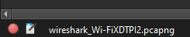

How many packets have passed through the interface?

From the Packet Detail Panel, within the GET command, what is the value of the Host?
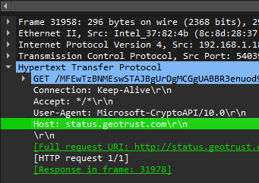

Status.geotrust.com\r\n

Can you see the Hex and ASCII representation of the packet in the Packet Bytes Panel?

Yes
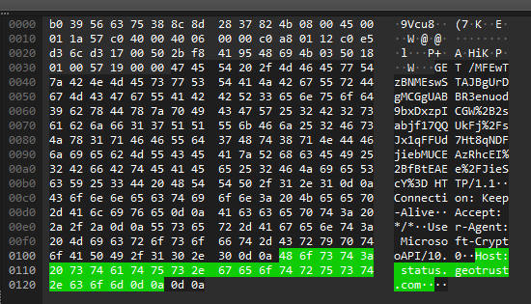

From the Packet Bytes Panel, what are the first 4 bytes of the Hex value of the Host
parameter?
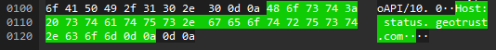

48 6f 73 74

What are the manufacturers of your PC's Network Interface card (NIC) and the server's NIC?
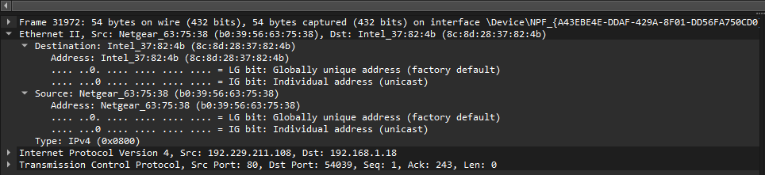
My PC (Destination): Intel
Server (Source): Netgear

What are the Hex values(show the raw bytes panel of the two NICS Manufacturers OUIs?

Destination: 8c:8d:28:37:82:4b
Source: b0:39:56:63:75:38

5.2.4
Can you identify the rest of the TCP 3-way handshake easily?
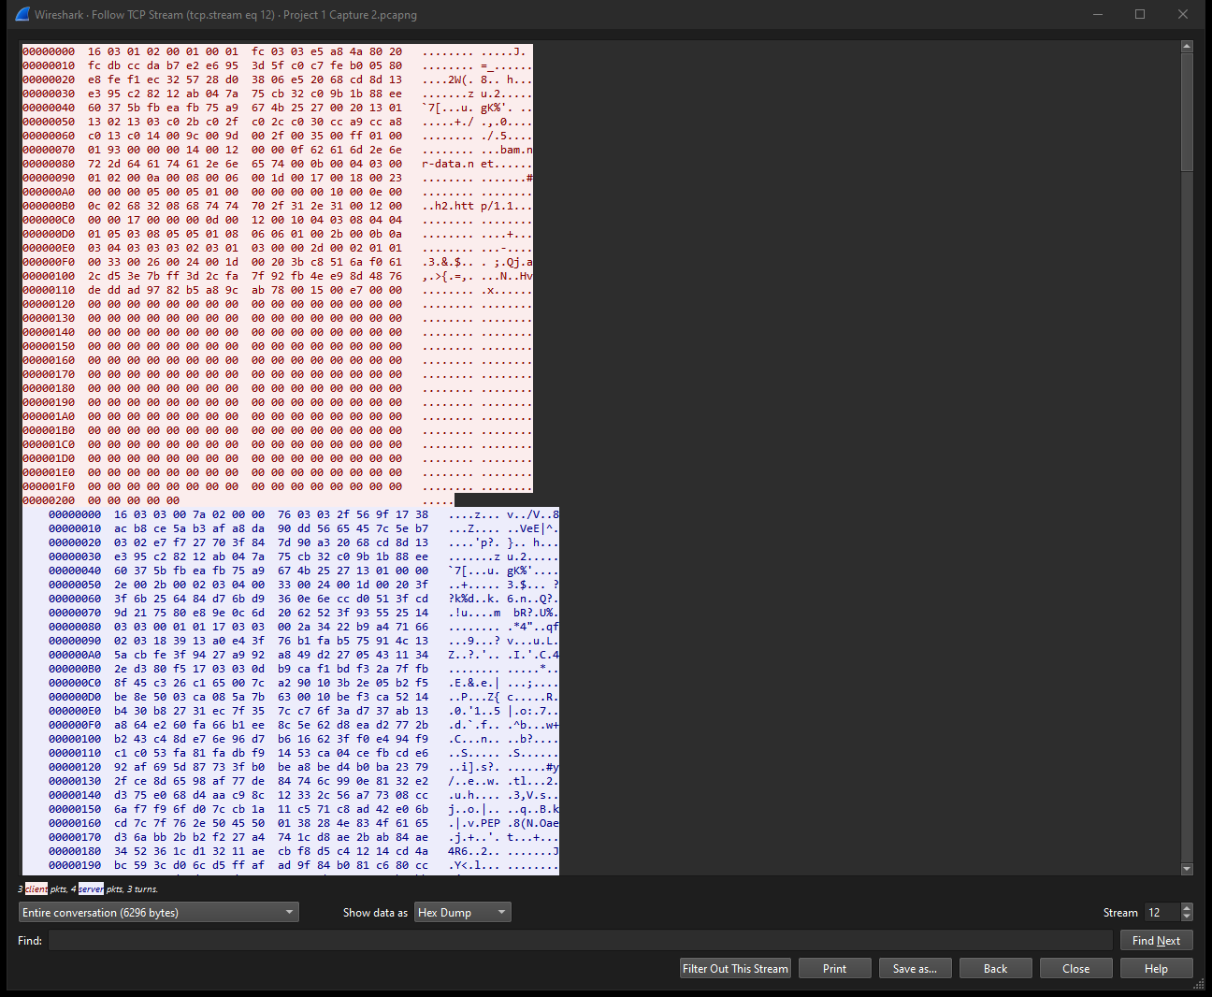

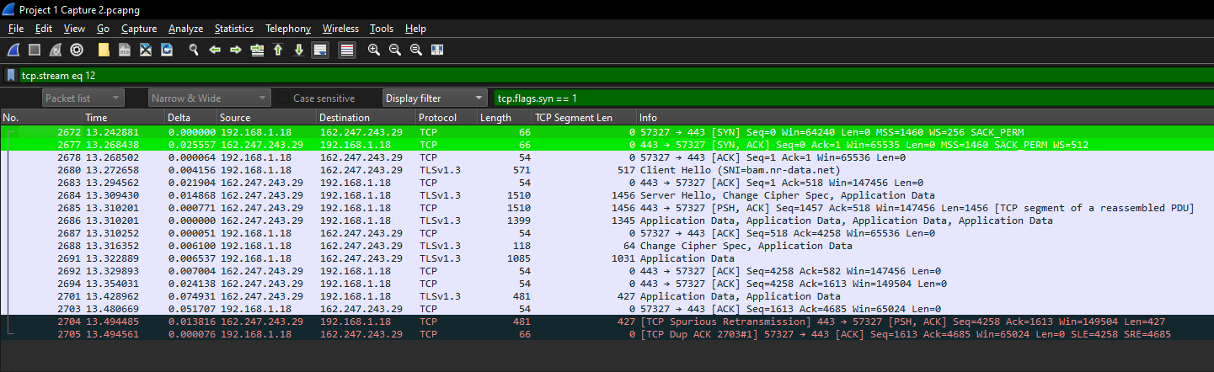

From your Wireshark Capture, fill in the diagram below with the IP address and Port Number of the Client and the server.

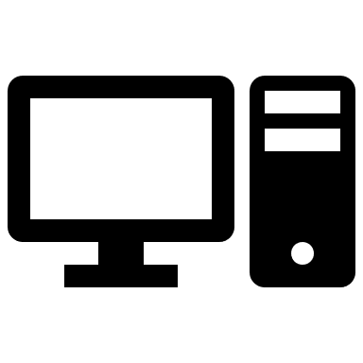 Flags: SYN, Seq: 0 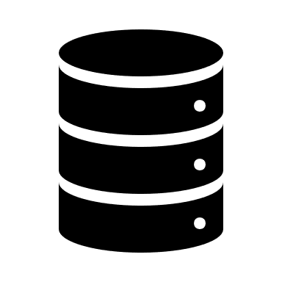
Client Server
IP Address: Flags: SYN, ACK Seq: 0 , ACK: 1 IP Address:
192.168.1.18 162.247.243.29
Port Number: Flags: ACK, Seq: 1 , ACK: 1 Port Number:
57327 443

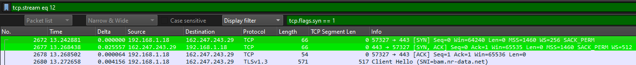

5.2.5

Copy the Display Filter into the clipboard, and close and start Wireshark again, then reload the file. Was the whole captured saved or just the displayed packet?
The whole packet that was captured is saved and reloaded when opened.
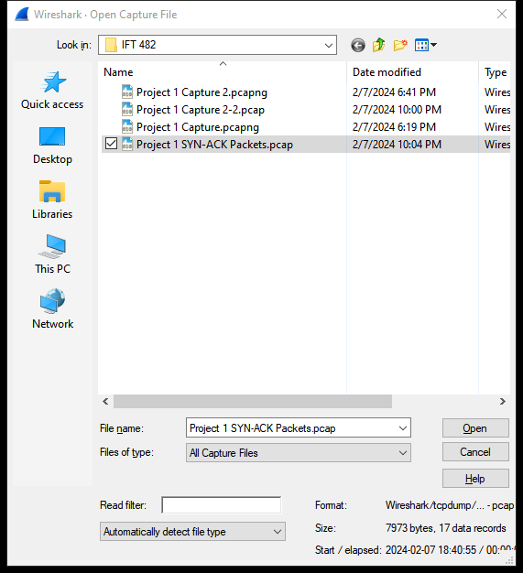
Close and start Wireshark again, then reload the file. Was the whole capture saved or just the
displayed packets?
Close and start Wireshark again, then reload the file. Was the whole capture saved or just the
displayed packets
Close and start Wireshark again, then reload the file. Was the whole capture saved or just the displayed packets?
Only the displayed packets were saved and displayed when reopened.
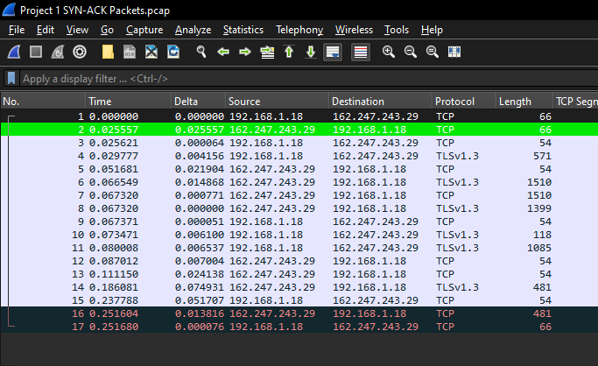

5.2.6

What percentage of packets in your capture are TCP, and gives an example of the higher-level protocol which uses TCP?
I had 97.9% of y packets come out to be TCP.
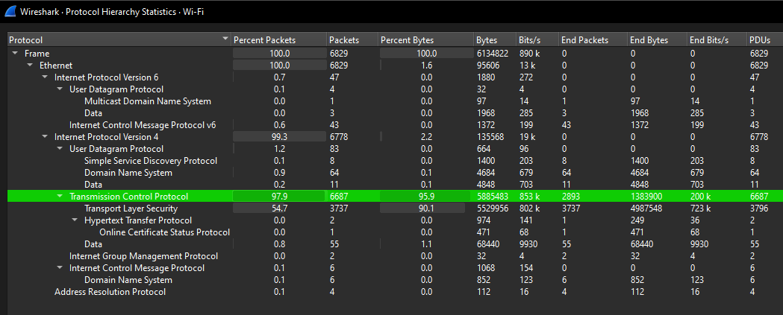
What percentage of packets in your captured are UDP, and give an example of the higher-level protocol which uses UDP?
1.2% were UDP.
DNS protocol uses UDP.

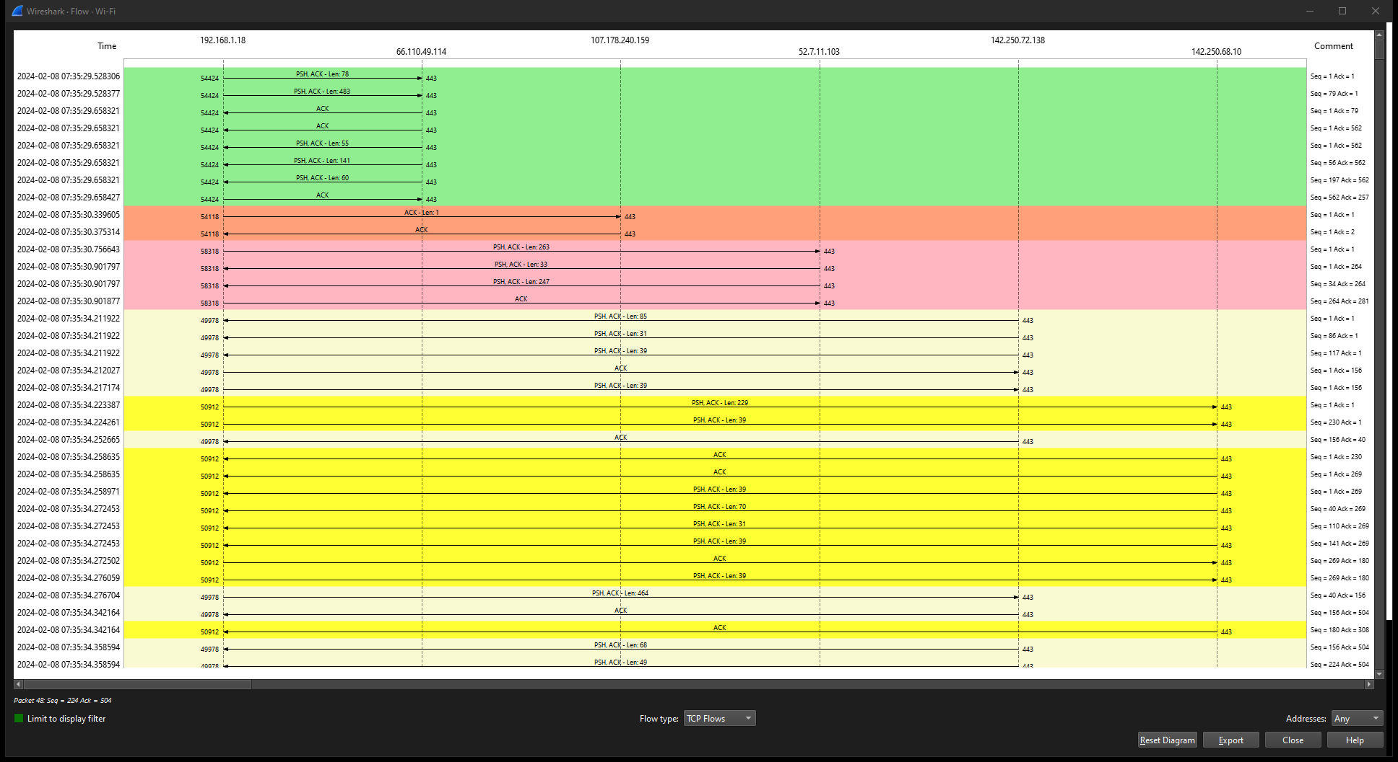

5.2.7

Screenshot of successful ping of local IP 192.168.1.2:
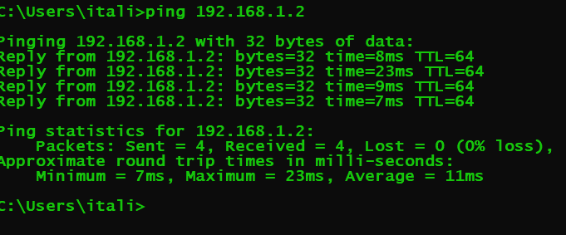

After the first command, are the ARP and ICMP packets captured by Wireshark? Yes
Display Filter for ICMP protocol:
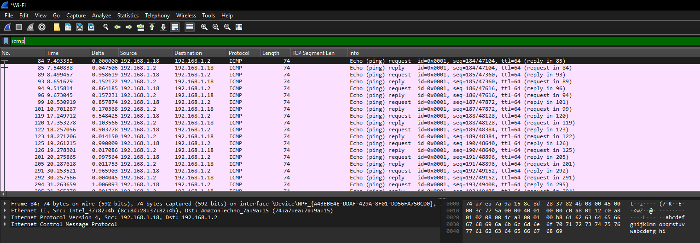

Display filter for ARP protocol:
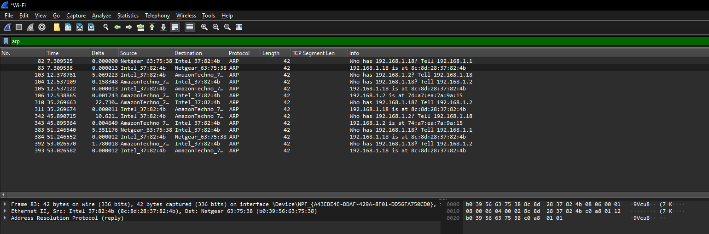

After a second or third ping command, is the ARP and ICMP packets captured by Wireshark?
ARP: Yes
ICMP: Yes

Why is this?

ARP (Address Resolution Protocol) and ICMP (Internet Control Message Protocol) requests continue to be sent as long as there is a need for devices to resolve IP addresses to MAC addresses (ARP) or to perform network diagnostics and management tasks (ICMP).

Here are some scenarios where ARP and ICMP requests would continue to be sent:

1. ARP Requests: ARP requests are sent by devices to resolve the MAC address of a destination IP address within the same local network segment. Whenever a device needs to communicate with another device on the same subnet, it sends an ARP request to discover the MAC address associated with the IP address it wants to reach. This process is fundamental for local network communication and will continue as long as devices on the network need to communicate with each other.

2. ICMP Requests: ICMP requests, such as ping, are used for various network diagnostic purposes, including checking the reachability of a host, measuring round-trip times, and detecting network congestion. These requests are often sent by network administrators or automated network monitoring tools to assess network performance and troubleshoot connectivity issues. As long as there is a need to diagnose network problems or monitor network performance, ICMP requests will continue to be sent.

5.2.9

Are the packets the same as the ping packets from the capture in the previous section?
ARP Filter:
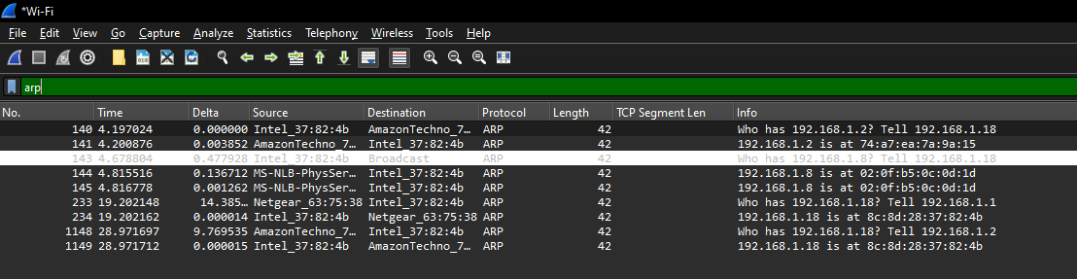
ICMP Filter:
Only ICMP v6 protocols come through:
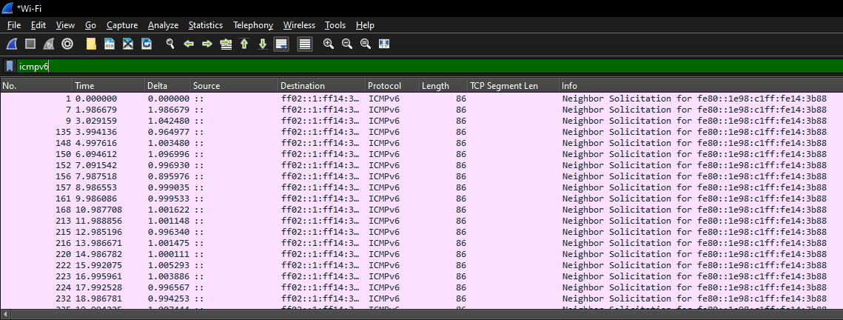

What type of packets are sent by Nmap?
ARP Packets

Are any other packets send by Nmap, during the ICMP prob?
There are no standard ICMP packets.

Are the packets the same as the ping packets from the capture in section 6?
Yes they are similar.
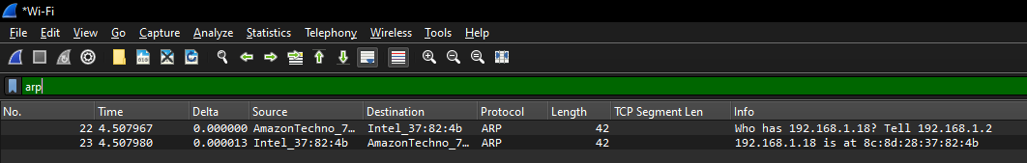
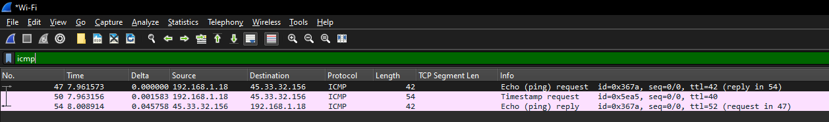

What different type of packets are sent by Nmap?
It sends ARP requests and ICMP packets.

Are any other packets sent by Nmap, during the host scan? Which protocol and to which port?
Yes.
TCP – Ports = 80,443, 53085, 53140, 53402, 53597, 59512, 53678, 43710, 52119, 53744.

Which OS is the scanned machine running?
Windows
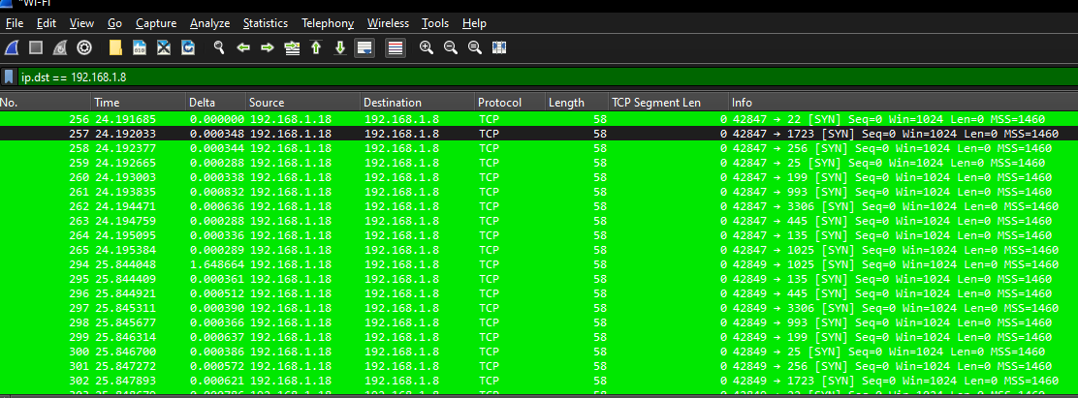

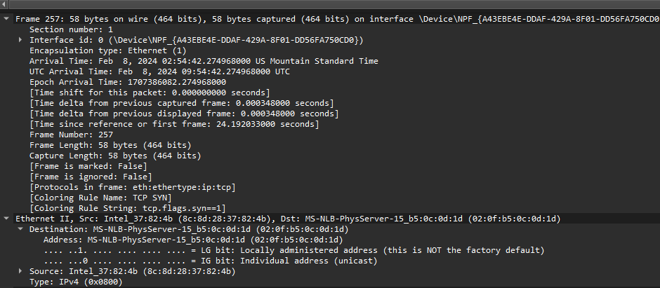
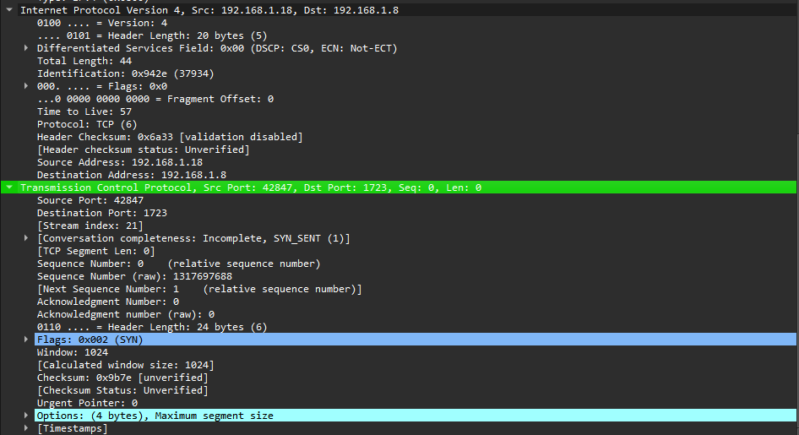

How many ports have been scanned in total? How many are open?
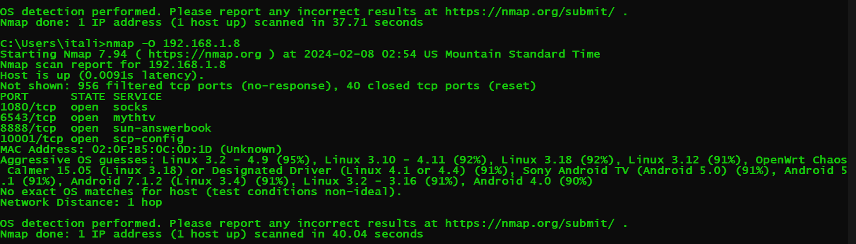
996 total ports scanned in total.
4 ports are open.
1080, 6543, 8888, 10001

Which Nmap command allows the scanning of custom range of ports?
'Nmap -p (yourportnumberhere)' allows the scanning of custom range ports.

Give an example of the following Nmap command, and what implication it might have for an IDs?
-T' flag stands for the port scan time, and paranoid is the 300sec wait and scan command.

Why might attacker change the timing of a scan?
An attacker might change the timing of an Nmap port scan for several reasons, primarily to evade detection or to gather more accurate information about the target network. Here are some potential motivations:

1. Evading Intrusion Detection Systems (IDS): By altering the timing of the port scan, an attacker can attempt to bypass intrusion detection systems that monitor network traffic for suspicious patterns. Some IDS systems are configured to trigger alerts based on the frequency or intensity of network scans. By using different timing options in Nmap, an attacker can try to avoid triggering these alerts.

2. Reducing Network Visibility: Scanning a network too quickly or too aggressively can generate a significant amount of network traffic, which may be easier to detect by network administrators or security monitoring tools. Slowing down the scan or spreading it out over a longer period can help reduce the visibility of the attacker's activities.

3. Gathering Accurate Information: Different timing options in Nmap, such as timing templates (e.g., `-T0` through `-T5`) or specific timing options (e.g., `--max-rtt-timeout`, `--initial-rtt-timeout`), can affect how quickly Nmap sends packets and how long it waits for responses. By adjusting these parameters, an attacker can gather more accurate information about the target network's responsiveness, network latency, and firewall behavior.

4. Avoiding Resource Exhaustion: Performing a port scan too quickly or with too many concurrent connections can overload network devices or target systems, leading to packet loss, resource exhaustion, or even crashing the systems. By adjusting the timing of the scan, an attacker can mitigate the risk of causing disruptions to the target network or attracting unwanted attention.

5. Enhancing Stealth: Slowing down the port scan can make it more difficult for network defenders to detect and respond to the attacker's activities. By flying under the radar and avoiding sudden spikes in network traffic, the attacker may increase the chances of remaining undetected while gathering reconnaissance or launching subsequent attacks.

What is a network sniffer? Give example of sniffer?
A packet analyzer or packet sniffer is a computer program or computer hardware, such as a packet
capture appliance, that can intercept and log traffic that passes over a computer network or part of a
network. Packet capture is the process of intercepting and logging traffic.
Example: nmap -sP nmap.org
What is a network sniffer? Give example of sniffer?
A packet analyzer or packet sniffer is a computer program or computer hardware, such as a packet
capture appliance, that can intercept and log traffic that passes over a computer network or part of a
network. Packet capture is the process of intercepting and logging traffic.
Example: nmap -sP nmap.org
Basic Network Forensics

What is a network sniffer? Give example of sniffer?
A packet analyzer or packet sniffer is a computer program or computer hardware, such as a packet capture appliance, that can intercept and log traffic that passes over a computer network or part of a network. Packet capture is the process of intercepting and logging traffic.
Example: nmap -sP nmap.org

What is port scanning?
A port scanner is an application designed to probe a server or Host for open ports. Such an application may be used by administrators to verify the security policies of their networks and by attackers to identify network services running on a host and exploit vulnerabilities.

Name at least 5 types of port scans?
Port scanning is a technique used to discover open ports on a target system. Attackers use port scans to gather information about potential entry points into a network. There are several types of port scans, each with its own characteristics and objectives. Here are five common types:

1. TCP Connect Scan: In a TCP connect scan, the scanner attempts to establish a full TCP connection with the target ports. If a connection is successfully established, the port is marked as open. This type of scan is straightforward but can be easily detected by intrusion detection systems (IDS) and firewalls.

2. SYN Scan (Half-open Scan): SYN scanning is a stealthier approach compared to TCP connect scanning. In a SYN scan, the scanner sends SYN packets to the target ports and listens for SYN/ACK responses. If a SYN/ACK response is received, it indicates that the port is open. This type of scan doesn't complete the full TCP handshake, making it less likely to be logged by IDS.

3. FIN Scan: In a FIN scan, the scanner sends FIN packets to the target ports. If the port is closed, the target system should respond with an RST packet. However, if the port is open, it should ignore the FIN packet, and no response will be sent. This technique can be used to determine whether a port is open or closed without completing the TCP handshake.

4. XMAS Scan: The XMAS scan is similar to the FIN scan but sends packets with the FIN, URG, and PSH flags set. The idea is to probe the target ports with unusual combinations of flags to determine their state. Like the FIN scan, an open port should ignore the packet, while a closed port should respond with an RST packet.

5. NULL Scan: In a NULL scan, the scanner sends TCP packets with no flags set (NULL packets) to the target ports. The behavior of the target system's response to NULL packets helps determine whether the port is open or closed. This scan relies on the fact that some systems may respond differently to NULL packets based on the port's state.

For Each type of scan listed above, if a network traffic dump is given, describe methods to identify packets that belong to the scans above.
Identifying packets belonging to different types of port scans in a network traffic dump requires careful analysis of the packet headers and their behavior. Here are methods to identify packets associated with each type of scan:

1. TCP Connection Scan:
- Look for packets with a complete TCP handshake sequence: SYN, SYN/ACK, and ACK.
- These scans establish full TCP connections, so you should observe a three-way handshake for each connection attempt.
- Check for sequences of SYN packets followed by SYN/ACK and ACK packets.

2. SYN Scan:
- Look for packets with the SYN flag set in the TCP header.
- SYN scans typically don't complete the TCP handshake, so you won't see ACK packets following SYN packets.
- Look for individual SYN packets sent to various target ports without completing the connection.

3. FIN Scan:
- Look for packets with the FIN flag set in the TCP header.
- In a FIN scan, the attacker sends packets with the FIN flag to target ports.
- Look for packets where the FIN flag is set, and analyze the response from the target system. Closed ports should respond with RST packets.

4. XMAS Scan:
- Look for packets with the FIN, URG, and PSH flags set simultaneously in the TCP header.
- XMAS scans attempt to probe ports using unusual combinations of flags.
- Identify packets with these specific flag combinations, and analyze the responses from the target system.

5. NULL Scan:
- Look for packets with no flags set in the TCP header (NULL packets).
- NULL scans involve sending TCP packets with all flags cleared.
- Identify packets with empty flag fields and observe the behavior of the target system's response. Closed ports should respond with RST packets.

Explain what a distributed slow scan is and how it is carried out?
A distributed slow scan is a type of port scanning technique that involves spreading out the scanning activity across multiple sources (computers or devices) over an extended period. The objective of a distributed slow scan is to avoid detection by security monitoring systems while gathering information about the target network.

Here's how a distributed slow scan is typically carried out:

1. Distribution of Scanning Activity: Instead of conducting the entire port scan from a single source, the scanning activity is distributed across multiple sources. These sources can be compromised computers (botnets), systems controlled by the attacker, or even unwitting participants whose devices are unknowingly used in the scan (e.g., through malware).

2. Slow and Low-Profile Scanning: The scanning activity is intentionally slowed down and conducted in a low-profile manner to avoid triggering alarms or detection mechanisms. Unlike traditional port scans that might flood the network with packets, a distributed slow scan sends out packets at a much slower rate and with less conspicuous patterns.

3. Randomized Timing: The timing of the scanning activity is randomized across the distributed sources. This randomness helps prevent the scanning activity from being easily identified as a coordinated attack. By staggering the scanning activity, it becomes more difficult for security systems to correlate the activities across multiple sources.

4. Varying Scan Parameters: To further evade detection, the attackers may vary the scan parameters such as the scan rate, ports scanned, and IP addresses targeted. By changing these parameters dynamically, the scan appears more like legitimate network traffic, making it harder to distinguish from normal activity.

5. Use of Proxies and Anonymization Techniques: Attackers may employ proxies and anonymization techniques to obfuscate the origin of the scanning activity. By routing the scanning traffic through multiple intermediary systems, they can hide the true source of the scan and make it harder for defenders to trace back to the attacker.

Can a TCP connection be spoofed? If so, how? If not, why not?
Yes, a TCP connection can be spoofed, albeit it's a challenging task and may require a sophisticated understanding of TCP/IP protocols and network architecture. Spoofing a TCP connection involves forging packets to mimic the behavior of legitimate TCP connections. Here's how it can be done:

1. IP Address Spoofing: An attacker can spoof the source IP address in the TCP packets to make it appear as if they are originating from a different machine or network. By forging the source IP address, the attacker can deceive the target system into believing that the packets are coming from a trusted source.

2. TCP Sequence Number Prediction: TCP sequence numbers are used to ensure the correct ordering of packets and to prevent packet injection attacks. However, if an attacker can predict or guess the sequence numbers used in a TCP connection, they can potentially inject malicious packets into the connection stream, effectively hijacking the connection.

3. TCP Session Hijacking: In a TCP session hijacking attack, an attacker intercepts an ongoing TCP connection between two parties and injects their own packets into the stream. This can be achieved by guessing or sniffing the sequence numbers used in the TCP connection and forging packets with those sequence numbers.

4. Man-in-the-Middle (MITM) Attacks: In a MITM attack, the attacker positions themselves between the client and server and intercepts the TCP connection. By relaying the packets between the client and server, the attacker can manipulate the traffic, modify data, or inject malicious payloads into the connection.

However, there are several challenges and limitations to spoofing TCP connections:

- Sequence Number Prediction: Predicting TCP sequence numbers can be difficult, especially in modern TCP implementations that use more sophisticated randomization techniques to generate sequence numbers.

- Firewalls and Intrusion Detection Systems (IDS): Firewalls and IDS systems often employ techniques to detect and prevent spoofed TCP connections. They may inspect packet headers, analyze traffic patterns, and use heuristics to identify suspicious activity.

- Encryption and Authentication: Encrypted and authenticated communication protocols such as TLS (Transport Layer Security) can prevent attackers from tampering with TCP connections, as they ensure the integrity and confidentiality of the data exchanged between parties.

Can a computer spoof a TCP connection to frame another computer in the same broadcast domain? If so, explain in detail how? If not, explain why not?
Yes, a computer can spoof a TCP connection to frame another computer in the same broadcast domain. This type of attack is known as a TCP/IP hijacking or session hijacking attack. In a broadcast domain, all devices connected to the same network segment can receive and potentially respond to broadcast traffic, making it possible for an attacker to impersonate another computer.

Here's how a computer can spoof a TCP connection to frame another computer in the same broadcast domain:

1. ARP Spoofing/Poisoning: The attacker first performs an ARP spoofing attack to poison the ARP cache of the target computer and the default gateway/router. By sending forged ARP (Address Resolution Protocol) messages, the attacker associates their own MAC address with the IP address of the target computer. As a result, traffic intended for the target computer is redirected to the attacker's machine.

2. Monitoring Traffic: Once the ARP cache is poisoned, the attacker's machine starts intercepting traffic intended for the target computer. The attacker monitors the ongoing TCP connections between the target computer and other hosts on the network.

3. Session Hijacking: When the attacker identifies a TCP session of interest, they begin hijacking the session by injecting forged TCP packets into the stream. This typically involves guessing or sniffing the sequence numbers used in the TCP connection.

4. Sequence Number Prediction: The attacker tries to predict the sequence numbers used in the TCP connection. Sequence numbers are used to ensure the correct ordering of packets and to prevent packet injection attacks. If the attacker successfully predicts the sequence numbers, they can inject malicious packets into the connection stream.

5. Packet Injection: Once the attacker has successfully predicted the sequence numbers, they inject forged TCP packets into the connection stream. These forged packets may contain commands or data intended to manipulate the target's behavior or compromise its security.

It's important to note that ARP spoofing attacks and TCP session hijacking are serious security threats and can lead to various forms of network abuse, data theft, and unauthorized access. To mitigate the risk of these attacks, network administrators should implement security best practices such as:

- Using secure network protocols like ARP spoofing prevention techniques (e.g., ARP inspection).
- Employing network intrusion detection/prevention systems (NIDS/NIPS) to detect and block suspicious traffic.
- Implementing strong encryption and authentication mechanisms to protect sensitive data.
- Regularly monitoring network traffic for signs of anomalous behavior and unauthorized access.

Analysis of Results (10 Points)
Throughout this project, I engaged in various tasks that provided me with valuable insights into the functionalities of Wireshark and Nmap software. Recognizing that reconnaissance is a critical first step in hacking or penetration testing, I discovered that Wireshark and Nmap are among the standard tools widely utilized for this purpose. By delving into this project, I acquired the skills to effectively filter data packets based on specific criteria, discern the appropriate scan types for host or operating system discoveries, and understand the nature of packets transmitted during each scan. I gained a deeper appreciation for the significance of both Wireshark and Nmap in network analysis and reconnaissance. Understanding how to leverage both tools simultaneously has proven advantageous, allowing me to gain a more comprehensive understanding of the network landscape and identify potential vulnerabilities more effectively. Such knowledge is not only valuable from a network forensic perspective but also instrumental in resolving network issues and enhancing overall security measures.

Summary and Conclusions (10 Points)
In this project, I utilized Wireshark, a packet-sniffing tool, and Nmap for host and open port discoveries within a network. Initially, I learned to navigate Wireshark by selecting the interface for packet sniffing, followed by the process of saving and reloading captured packets onto disk. Subsequently, I acquired proficiency in applying filters to isolate relevant packets for analysis. Additionally, I explored Nmap and its diverse range of scans for uncovering hosts and open ports.

The project provided valuable insights into host scanning methodologies, emphasizing the significance of tool familiarity in network discovery. Through the activity, I gained a deeper understanding of host scans, including the protocols and packets utilized for network reconnaissance. Moreover, I learned to synergize both Wireshark and Nmap to extract comprehensive insights into network behavior.

Utilizing Wireshark, I discovered its capability to capture all inbound and outbound traffic, enabling insight into browsing habits and unencrypted messages, while also revealing system IP and MAC addresses. Such knowledge is fundamental in network forensics, where understanding the target IP is crucial for investigative purposes.

